Essential I2b2 Web-client interactions:
Ricardo De Lima (Ricardo_Delima@hms.harvard.edu)

Here are a few of the most important client/server interactions that originate on web-client i2b2 interactions. I have omitted the calls to the Ontology cell and Workplace cell but for documentation purposes these occur right after successful login and are used to populate the appropriate UI elements on the web-client (i.e. “Navigation Terms” from the Ontology Cell and “Workplace” panel from the Workplace cell).

The web-client lives on http://services.i2b2.org/webclient/ user name and password: demo/demouser. After login on the top right a “Message Log” – a new window that will show you XML messages will come up, very useful for tracing and debugging.
Index Quick links
* Logging in a valid username/password (demo/demouser) [request xml ] [response xml]
* Logging in with an incorrect user/name password (demo/demo) [request xml ] [response xml]

PM Cell: Logging in a valid username/password (demo/demouser):

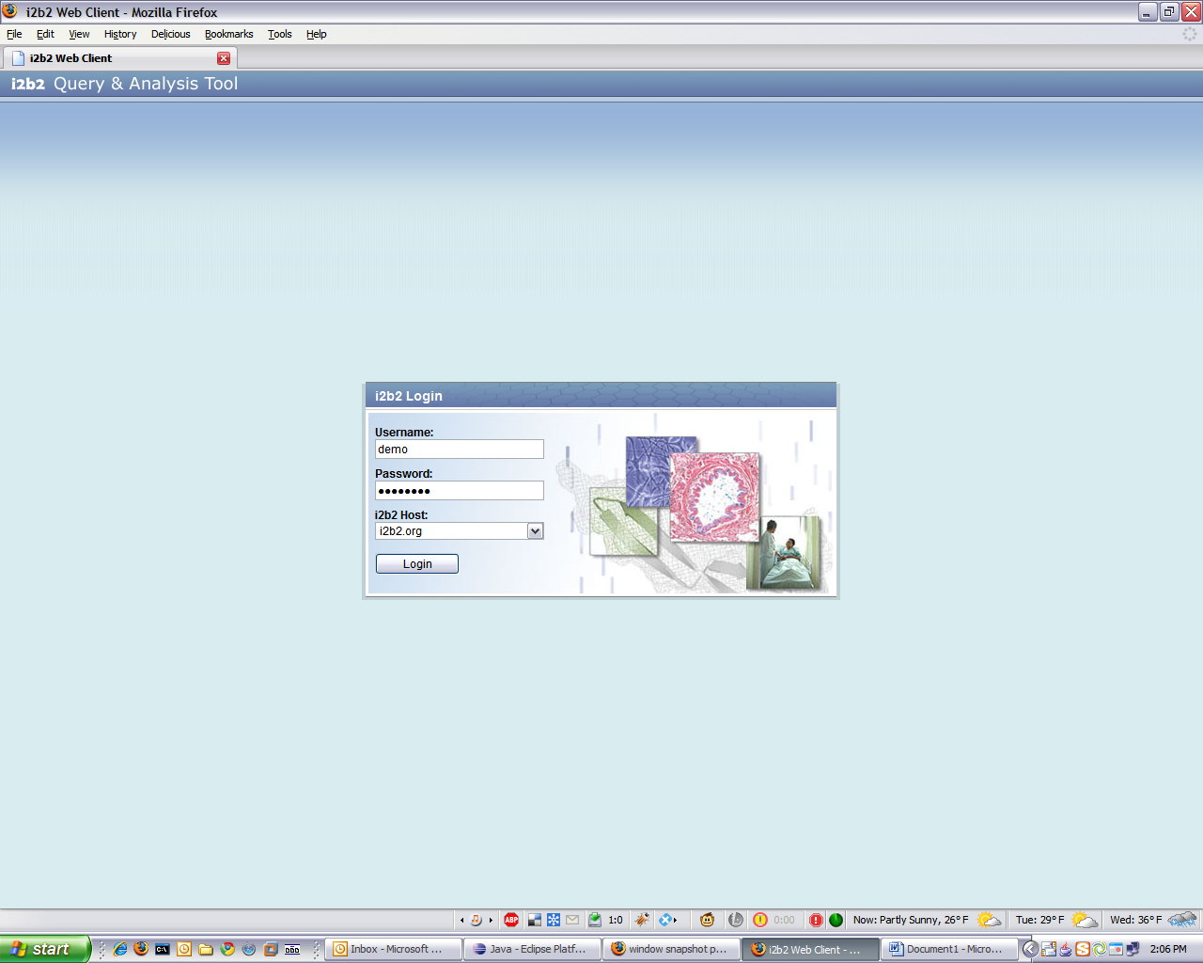

XML Request (generated by the web-client once LOGIN is submitted):

<?xml version="1.0" encoding="UTF-8" standalone="yes"?>
<i2b2:request xmlns:i2b2="http://www.i2b2.org/xsd/hive/msg/1.1/" xmlns:pm="http://www.i2b2.org/xsd/cell
/pm/1.1/">
<message_header>
<proxy>
<redirect_url>http://services.i2b2.org/PM/rest/PMService/getServices</redirect_url>
</proxy>
<i2b2_version_compatible>1.1</i2b2_version_compatible>
<hl7_version_compatible>2.4</hl7_version_compatible>
<sending_application>
<application_name>i2b2 Project Management</application_name>
<application_version>1.1</application_version>
</sending_application>
<sending_facility>
<facility_name>i2b2 Hive</facility_name>
</sending_facility>
<receiving_application>
<application_name>Project Management Cell</application_name>
<application_version>1.1</application_version>
</receiving_application>
<receiving_facility>
<facility_name>i2b2 Hive</facility_name>
</receiving_facility>
<datetime_of_message>2007-04-09T15:19:18.906-04:00</datetime_of_message>
<security>
<domain>HarvardDemo</domain>
<username>demo</username>
<password>demouser</password>
</security>
<message_control_id>
<message_num>Z388cRFJ6y5vt2Wwj06Nn</message_num>
<instance_num>0</instance_num>
</message_control_id>
<processing_id>
<processing_id>P</processing_id>
<processing_mode>I</processing_mode>
</processing_id>
<accept_acknowledgement_type>AL</accept_acknowledgement_type>
<application_acknowledgement_type>AL</application_acknowledgement_type>
<country_code>US</country_code>
<project_id>undefined</project_id>
</message_header>
<request_header>
<result_waittime_ms>180000</result_waittime_ms>
</request_header>
<message_body>
<pm:get_user_configuration>
<project>undefined</project>
</pm:get_user_configuration>
</message_body>
</i2b2:request>

RED: This is where this message is going to. Remember there is a “proxy” at the other end of this service (to break out of the sandbox) which forwards XML messages to the different cells (PM, CRC, Ontology) per the client request. This is how this is done, with a redirect_url tag that the proxy parses out of the XML and then re-POSTs the entire message to that address. The client always knows where the PM is (it’s in a configuration file that gets loaded when the web-client loads its UI and its in a property file for the Workbench UI) because a PM “defines” a Hive. All the other cells are discovered through the PM. More on this later.

YELLOW: Security tokens. Always present. In clear-text. Let’s move on.

GREEN: The PM message to obtain authentication/authorization (uses the security tokens above that are in the header). Note how the proxy info and the security tokens are in the header and the actual “query” of this message is in the body.

XML Response from the PM cell:

<?xml version="1.0" encoding="UTF-8"?>
<ns2:response xmlns:tns="http://ws.pm.i2b2.harvard.edu"
xmlns:ns3="http://www.i2b2.org/xsd/hive/msg/version
/"
xmlns:ns4="http://www.i2b2.org/xsd/cell/pm/1.1/"
xmlns:ns2="http://www.i2b2.org/xsd/hive/msg/1.1/">
<message_header>
<i2b2_version_compatible>1.1</i2b2_version_compatible>
<hl7_version_compatible>2.4</hl7_version_compatible>
<sending_application>
<application_name>PM Cell</application_name>
<application_version>1.1</application_version>
</sending_application>
<sending_facility>
<facility_name>i2b2 Hive</facility_name>
</sending_facility>
<receiving_application>
<application_name>PM Cell</application_name>
<application_version>1.1</application_version>
</receiving_application>
<receiving_facility>
<facility_name>i2b2 Hive</facility_name>
</receiving_facility>
<datetime_of_message>2009-01-27T15:09:11.654-05:00</datetime_of_message>
<message_control_id>
<message_num>Z388cRFJ6y5vt2Wwj06Nn</message_num>
<instance_num>1</instance_num>
</message_control_id>
<processing_id>
<processing_id>P</processing_id>
<processing_mode>I</processing_mode>
</processing_id>
<accept_acknowledgement_type>AL</accept_acknowledgement_type>
<application_acknowledgement_type>AL</application_acknowledgement_type>
<country_code>US</country_code>
<project_id>undefined</project_id>
</message_header>
<response_header>
<result_status>
<status type="DONE">PM processing completed </status>
</result_status>
</response_header>
<message_body>
<ns4:configure>
<environment>PRODUCTION</environment>
<helpURL>www.i2b2.org</helpURL>
<user>
<full_name>Demo User</full_name>
<user_name>demo</user_name>
<password>demouser</password>
<domain>HarvardDemo</domain>
<project id="Demo">
<name>Demo Group</name>
<wiki>www.i2b2.org </wiki>
<role>USER</role>
</project>
<project id="Demo2">
<name>Demo2 Group</name>
<wiki>www.i2b2.org</wiki>
<role>USER</role>
</project>
</user>
<cell_datas>
<cell_data id="CRC">
<name>Data Repository</name>
<url>http://services.i2b2.org/i2b2/rest/QueryToolService/</url>
<method>REST</method>
</cell_data>
<cell_data id="FRC">
<name>Data Importer Cell</name>
<url>http://services.i2b2.org/i2b2/services/FRService/</url>
<method>SOAP</method>
<param name="DestDir">/www/services.i2b2.org/FRC </param>
<param name="PathSeparator">/</param>
</cell_data>
<cell_data id="ONT">
<name>Ontology Service</name>
<url>http://services.i2b2.org/i2b2/rest/OntologyService/</url>
<method>REST</method>
<param name="OntMax">300</param>
<param name="OntHiddens">false </param>
<param name="OntSynonyms">false</param>
</cell_data>
<cell_data id="PFT">
<name>PFT Cell</name>
<url>http ://services.i2b2.org/PM/rest/PFTService/</url>
<method>REST</method>
</cell_data>
<cell_data id="WORK">
<name>Workplace Cell</name>
<url>http://services.i2b2.org/i2b2/rest/WorkplaceService/</url>
<method>REST</method>
</cell_data>
</cell_datas>
</ns4:configure>
</message_body>
</ns2:response>

GREEN: This is the PM message reply per se. Note how the status is in the header and the PM user configuration is in the body. When the authentication/authorization succeeds the PM returns the “projects” the user has access to as well as the list of cells the user has access to (all this is configured on the server). There is some metadata associated with each CELL, of all the most important; the REST/SOAP method is ignored by the web-client. It is all HTTP POSTs to the URL indicated (what they call REST).

PM Cell: Logging in with an incorrect user/name password (demo/demo)

Request XML: (most XML omitted for brevity):

<security>
<domain>HarvardDemo</domain>
<username>demo</username>
<password>demo</password>
</security>

Response XML:

<?xml version="1.0" encoding="UTF-8" standalone="yes"?>
<ns2:response xmlns:tns="http://ws.pm.i2b2.harvard.edu"
xmlns:ns3="http://www.i2b2.org/xsd/hive/msg/version
/"
xmlns:ns4="http://www.i2b2.org/xsd/cell/pm/1.1/"
xmlns:ns2="http://www.i2b2.org/xsd/hive/msg/1.1/">
<message_header>
<i2b2_version_compatible>1.1</i2b2_version_compatible>
<hl7_version_compatible>2.4</hl7_version_compatible>
<sending_application>
<application_name>PM Cell</application_name>
<application_version>1.1</application_version>
</sending_application>
<sending_facility>
<facility_name>i2b2 Hive</facility_name>
</sending_facility>
<receiving_application>
<application_name>PM Cell</application_name>
<application_version>1.1</application_version>
</receiving_application>
<receiving_facility>
<facility_name>i2b2 Hive</facility_name>
</receiving_facility>
<datetime_of_message>2009-01-27T15:47:24.810-05:00</datetime_of_message>
<message_control_id>
<message_num>YDJPIe281S5z1bTgQtuCH</message_num>
<instance_num>1</instance_num>
</message_control_id>
<processing_id>
<processing_id>P</processing_id>
<processing_mode>I</processing_mode>
</processing_id>
<accept_acknowledgement_type>AL</accept_acknowledgement_type>
<application_acknowledgement_type>AL</application_acknowledgement_type>
<country_code>US</country_code>
<project_id>undefined</project_id>
</message_header>
<response_header>
<result_status>
<status type="ERROR">Supplied password does not match user password!</status>
</result_status>
</response_header>
</ns2:response>

GREEN: This is the PM indicating a failure authentication/authorization. Note how this error message is not best practice for auth/auth failure.

Passing a false user name would result in:

<status type="ERROR">Username does not exist</status>

CRC Cell: Getting the Previous Queries by a User

This happens automatically at login to populate the bottom left panel with a history of “Previous Queries” the user has executed on this system:

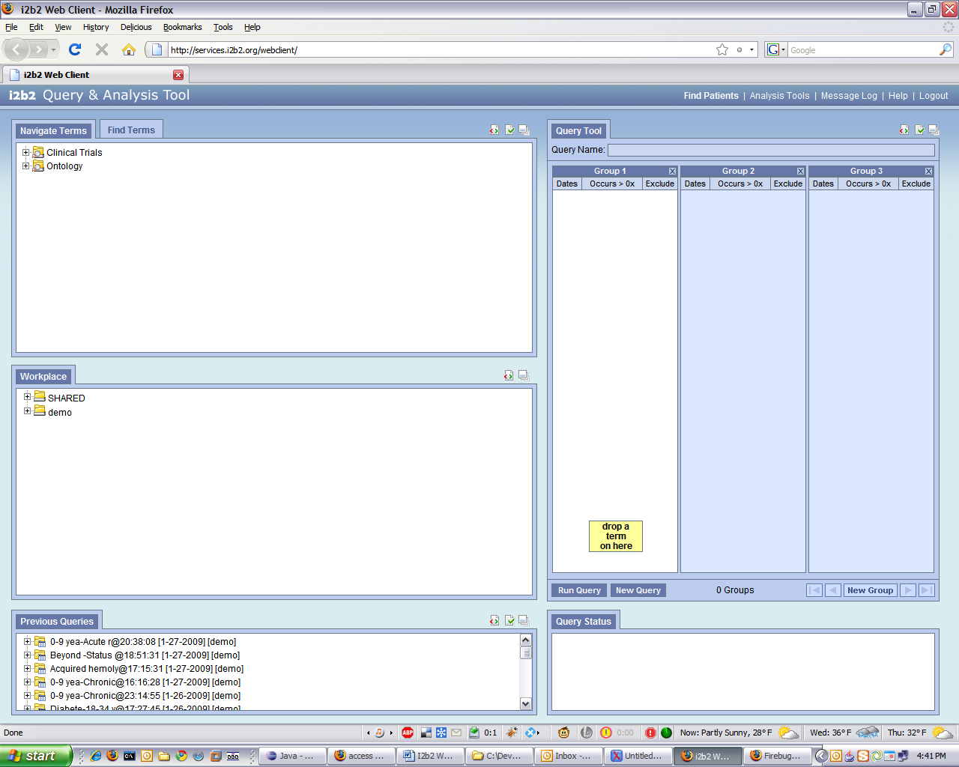

Request XML:

<?xml version="1.0" encoding="UTF-8" standalone="yes"?>
<ns6:request xmlns:ns4="http://www.i2b2.org/xsd/cell/crc/psm/1.1/" xmlns:ns7="http://www.i2b2.org/xsd
/cell/crc/psm/querydefinition/1.1/" xmlns:ns3="http://www.i2b2.org/xsd/cell/crc/pdo/1.1/" xmlns:ns5="http
://www.i2b2.org/xsd/hive/plugin/" xmlns:ns2="http://www.i2b2.org/xsd/hive/pdo/1.1/" xmlns:ns6="http:
//www.i2b2.org/xsd/hive/msg/1.1/">
<message_header>
<proxy>
<redirect_url>
http://services.i2b2.org/i2b2/rest/QueryToolService/request
</redirect_url>
</proxy>
<sending_application>
<application_name>i2b2_QueryTool</application_name>
<application_version>0.2</application_version>
</sending_application>
<sending_facility>
<facility_name>PHS</facility_name>
</sending_facility>
<receiving_application>
<application_name>i2b2_DataRepositoryCell</application_name>
<application_version>0.2</application_version>
</receiving_application>
<receiving_facility>
<facility_name>PHS</facility_name>
</receiving_facility>
<security>
<domain>HarvardDemo</domain>
<username>demo</username>
<password>demouser</password>
</security>
<message_type>
<message_code>Q04</message_code>
<event_type>EQQ</event_type>
</message_type>
<message_control_id>
<message_num>yCqS6AUSZZ5MxsBP96byH</message_num>
<instance_num>0</instance_num>
</message_control_id>
<processing_id>
<processing_id>P</processing_id>
<processing_mode>I</processing_mode>
</processing_id>
<accept_acknowledgement_type>AL</accept_acknowledgement_type>
<project_id>Demo</project_id>
<country_code>US</country_code>
</message_header>
<request_header>
<result_waittime_ms>180000</result_waittime_ms>
</request_header>
<message_body>
<ns4:psmheader>
<user login="demo">demo</user>
<patient_set_limit>0</patient_set_limit>
<estimated_time>0</estimated_time>
<request_type>
CRC_QRY_getQueryMasterList_fromUserId
</request_type>
</ns4:psmheader>
<ns4:request xsi:type="ns4:user_requestType" xmlns:xsi="http://www.w3.org/2001/XMLSchema-instance"
>
<user_id>demo</user_id>
<group_id>demo</group_id>
<fetch_size>20</fetch_size>
</ns4:request>
</message_body>
</ns6:request>

GREEN: First, in the message header we have a result_waittime_ms tag. This is the maximum amount of time the client is willing to wait for a query reply. The client sets this number. Currently the web-client is hardcoded to tell the CRC (and any other cells) to execute a query for up to 180 seconds. The CRC will read the value <result_waittime_ms> from the <request_header> and if the query did not complete before the wait time specified in the request, it will send a response to the client with “RUNNING” status.

After this then follows the containing the psmheader, starting the proper CRC query.

Note the <fetch_size> tag; it is used to control the maximum number of QueryMaster (s) that will be returned by the CRC.

The CRC Model for the “Patient Set Query Service”

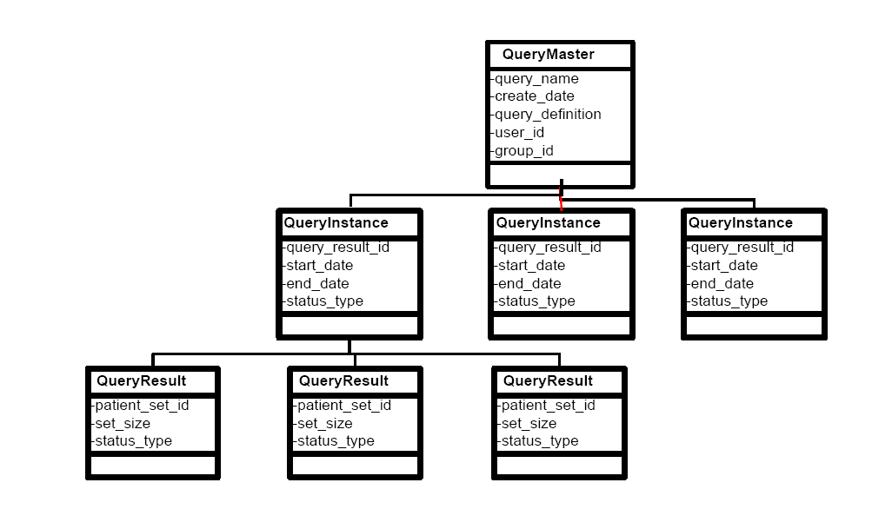

To clarify, in the CRC model, the “QueryMaster” is the type that holds the query name and definition (this gets persisted in a history at the CRC per each user). Each “QueryMaster” may have multiple instances “QueryInstances”, that is, each query may be performed multiple times from the same “QueryMaster” (e.g. at different times). A QueryInstance holds information about the execution of the query per se, start date/end date, status, and one or more “QueryResult” id. A QueryInstance (an executed version of a QueryMaster) may contain multiple “QueryResult”. For example it is possible to ask in the same query for an aggregate patient count (<result_output name="PATIENT_COUNT_XML"/> in the query definition), a gender count ((<result_output name="PATIENT_GENDER_COUNT_XML”/>) and the “set” of patients (<result_output name="PATIENTSET"/>), a patient “set” being the CRC concept of persisting The patient set from the query in the database.

The CRC also offers another embedded service (once you have created a “set” with a PSM query, also called a “set finder” query in CRC documentation), called the Patient Object Data Query Service (PDO).

It seems that for our current purposes we are only concerning ourselves with the (<result_output name="PATIENT_COUNT_XML"/>) type of query from the Patient Set Query Service (PSM). (ED: Needs confirmation)

As an architectural detail of the CRC, both the PSM and the PDO run from the same codebase but are listening to requests in different URLs. For example the PSM listens on http://services.i2b2.org/i2b2/rest/QueryToolService/request and the PDO listens on http://services.i2b2.org/i2b2/rest/QueryToolService/pdorequest.

Response XML of CRC_QRY_getQueryMasterList_fromUserId:

(Abbreviated)

<ns5:response xmlns:tns="http://axis2.crc.i2b2.harvard.edu"
xmlns:ns9="http://www.i2b2.org/xsd/hive/msg/result/1.1/"
xmlns:ns4="http://www.i2b2.org/xsd/cell/crc/psm/1.1/"
xmlns:ns7="http://www.i2b2.org/xsd/cell/pm/1.1/"
xmlns:ns3="http://www.i2b2.org/xsd/cell/crc/pdo/1.1/"
xmlns:ns5="http://www.i2b2.org/xsd/hive/msg/1.1/"
xmlns:ns2="http://www.i2b2.org/xsd/hive/pdo/1.1/"
xmlns:ns6="http://www.i2b2.org/xsd/cell/crc/psm/querydefinition/1.1/"
xmlns:ns8="http://www.i2b2.org/xsd/cell/ont/1.1/">
<message_header>
<i2b2_version_compatible>1.1</i2b2_version_compatible>
<hl7_version_compatible>2.4</hl7_version_compatible>
<sending_application>
<application_name>edu.harvard.i2b2.crc</application_name>
<application_version>1.3</application_version>
</sending_application>
<sending_facility>
<facility_name>i2b2 Hive</facility_name>
</sending_facility>
<receiving_application>
<application_name>i2b2_QueryTool</application_name>
<application_version>0.2</application_version>
</receiving_application>
<receiving_facility>
<facility_name>i2b2 Hive</facility_name>
</receiving_facility>
<message_control_id>
<instance_num>1</instance_num>
</message_control_id>
<project_id>Demo</project_id>
</message_header>
<response_header>
<info>Log information</info>
<result_status>
<status type="DONE">DONE</status>
<polling_url interval_ms="100"/>
</result_status>
</response_header>
<message_body>
<ns4:response xmlns:xsi="http://www.w3.org/2001/XMLSchema-instance"
xsi:type="ns4:master_responseType">
<status>
<condition type="DONE">DONE</condition>
</status>
<query_master>
<query_master_id>9025</query_master_id>
<name>0-9 yea-Acute r@00:19:48</name>
<user_id>demo</user_id>
<group_id>Demo</group_id>
<create_date>2009-01-27T19:19:56.000-05:00</create_date>
</query_master>

<query_master>
<query_master_id>9024</query_master_id>
<name>55-64 y-Male@21:12:01</name>
<user_id>demo</user_id>
<group_id>Demo</group_id>
<create_date>2009-01-27T16:12:10.000-05:00</create_date>
</query_master>

<query_master>
<query_master_id>9023</query_master_id>
<name>0-9 yea-Acute r@20:38:08</name>
<user_id>demo</user_id>
<group_id>Demo</group_id>
<create_date>2009-01-27T15:38:16.000-05:00</create_date>
</query_master>
</message_body>
</ns5:response>

GREEN: The status is set as DONE in both the header (<result_status>)and the body (<status>) (not clear why this repetition is necessary). Then the message includes several <query_master> entries (up to 20 as <fetch_size> requested).

CRC Cell: · Get an XML Definition of a Defined Query: CRC_QRY_getRequestXml_fromQueryMasterId

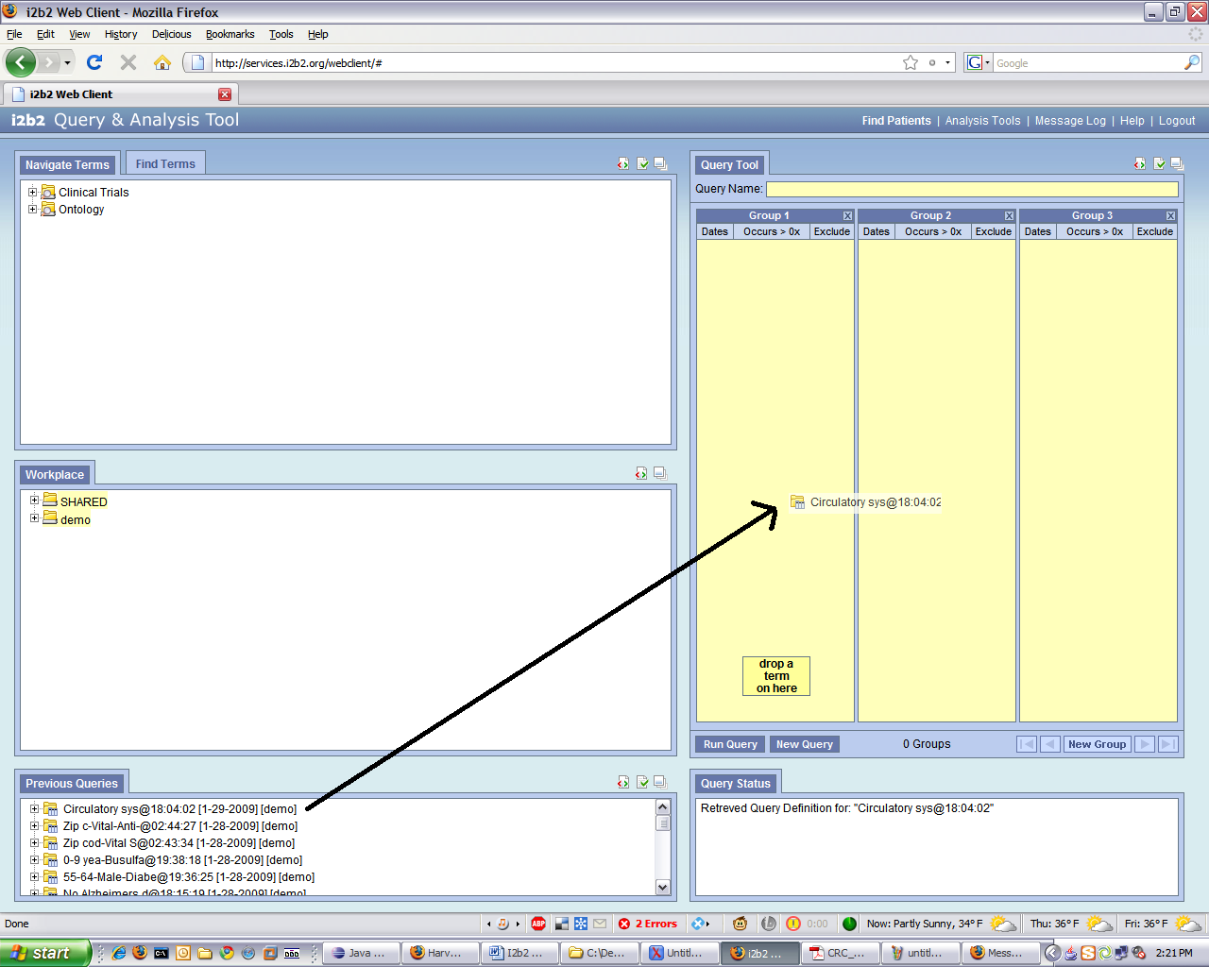

We’re dragging and dropping a previous query onto the query panel. This results in a CRC_QRY_getRequestXml_fromQueryMasterId call with the querymaster_id that was fetched by the CRC_QRY_getQueryMasterList_fromUserId call.

XML Request:

<?xml version="1.0" encoding="UTF-8" standalone="yes"?>
<ns6:request xmlns:ns4="http://www.i2b2.org/xsd/cell/crc/psm/1.1/" xmlns:ns7="http://www.i2b2.org/xsd/cell/crc/psm/querydefinition/1.1/" xmlns:ns3="http://www.i2b2.org/xsd/cell/crc/pdo/1.1/" xmlns:ns5="http://www.i2b2.org/xsd/hive/plugin/" xmlns:ns2="http://www.i2b2.org/xsd/hive/pdo/1.1/" xmlns:ns6="http://www.i2b2.org/xsd/hive/msg/1.1/">
<message_header>
<proxy>
<redirect_url>http://services.i2b2.org/i2b2/rest/QueryToolService/request</redirect_url>
</proxy>
<sending_application>
<application_name>i2b2_QueryTool</application_name>
<application_version>0.2</application_version>
</sending_application>
<sending_facility>
<facility_name>PHS</facility_name>
</sending_facility>
<receiving_application>
<application_name>i2b2_DataRepositoryCell</application_name>
<application_version>0.2</application_version>
</receiving_application>
<receiving_facility>
<facility_name>PHS</facility_name>
</receiving_facility>
<security>
<domain>HarvardDemo</domain>
<username>demo</username>
<password>demouser</password>
</security>
<message_type>
<message_code>Q04</message_code>
<event_type>EQQ</event_type>
</message_type>
<message_control_id>
<message_num>9dz6u2wZDdSU0D7cv7dJb</message_num>
<instance_num>0</instance_num>
</message_control_id>
<processing_id>
<processing_id>P</processing_id>
<processing_mode>I</processing_mode>
</processing_id>
<accept_acknowledgement_type>messageId</accept_acknowledgement_type>
<project_id>Demo</project_id>
</message_header>
<request_header>
<result_waittime_ms>180000</result_waittime_ms>
</request_header>
<message_body>
<ns4:psmheader>
<user login="demo">demo</user>
<patient_set_limit>0</patient_set_limit>
<estimated_time>0</estimated_time>
<request_type>CRC_QRY_getRequestXml_fromQueryMasterId</request_type>
</ns4:psmheader>
<ns4:request xsi:type="ns4:master_requestType" xmlns:xsi="http://www.w3.org/2001/XMLSchema-instance">
<query_master_id>9039</query_master_id>
</ns4:request>
</message_body>
</ns6:request>

GREEN: Just as before, <result_waittime_ms> of 180 seconds. Now the appropriate request_type is CRC_QRY_getRequestXml_fromQueryMasterId and the parameter input query_master_id: 9039. This is the pattern of operations for most of the calls.

Response XML:

<ns5:response xmlns:tns="http://axis2.crc.i2b2.harvard.edu"
xmlns:ns9="http://www.i2b2.org/xsd/hive/msg/result/1.1/"
xmlns:ns4="http://www.i2b2.org/xsd/cell/crc/psm/1.1/"
xmlns:ns7="http://www.i2b2.org/xsd/cell/pm/1.1/"
xmlns:ns3="http://www.i2b2.org/xsd/cell/crc/pdo/1.1/"
xmlns:ns5="http://www.i2b2.org/xsd/hive/msg/1.1/"
xmlns:ns2="http://www.i2b2.org/xsd/hive/pdo/1.1/"
xmlns:ns6="http://www.i2b2.org/xsd/cell/crc/psm/querydefinition/1.1/"
xmlns:ns8="http://www.i2b2.org/xsd/cell/ont/1.1/">
<message_header>
<i2b2_version_compatible>1.1</i2b2_version_compatible>
<hl7_version_compatible>2.4</hl7_version_compatible>
<sending_application>
<application_name>edu.harvard.i2b2.crc</application_name>
<application_version>1.3</application_version>
</sending_application>
<sending_facility>
<facility_name>i2b2 Hive</facility_name>
</sending_facility>
<receiving_application>
<application_name>i2b2_QueryTool</application_name>
<application_version>0.2</application_version>
</receiving_application>
<receiving_facility>
<facility_name>i2b2 Hive</facility_name>
</receiving_facility>
<message_control_id>
<instance_num>1</instance_num>
</message_control_id>
<project_id>Demo</project_id>
</message_header>
<response_header>
<info>Log information</info>
<result_status>
<status type="DONE">DONE</status>
<polling_url interval_ms="100"/>
</result_status>
</response_header>
<message_body>
<ns4:response xmlns:xsi="http://www.w3.org/2001/XMLSchema-instance"
xsi:type="ns4:master_responseType">
<status>
<condition type="DONE">DONE</condition>
</status>
<query_master>
<query_master_id>9039</query_master_id>
<name>Circulatory sys@18:04:02</name>
<user_id>demo</user_id>
<request_xml>
<ns2:query_definition
xmlns:ns2="http://www.i2b2.org/xsd/cell/crc/psm/querydefinition/1.1/">
<query_name>Circulatory sys@18:04:02</query_name>
<specificity_scale>0</specificity_scale>
<panel>
<panel_number>1</panel_number>
<panel_accuracy_scale>0</panel_accuracy_scale>
<invert>0</invert>
<total_item_occurrences>1</total_item_occurrences>
<item>
<hlevel>2</hlevel>
<item_name>Circulatory system</item_name>
<item_key>\\i2b2\i2b2\Diagnoses\Circulatory system
(390-459)\</item_key>
<item_icon>FA</item_icon>
<tooltip>Diagnoses \ Circulatory system</tooltip>
<class>ENC</class>
<constrain_by_date/>
<item_is_synonym>false</item_is_synonym>
</item>
</panel>
</ns2:query_definition>
</request_xml>
</query_master>
</ns4:response>
</message_body>
</ns5:response>

YELLOW: Why are there two statuses? This is not clear or well defined in any of these specs. It seems that the status <status> within the XML body is specific to the CRC. The status in the header <result_status> is a more generic i2b2 status shared by the PM, CRC, ONT cells. The question when is this status NOT set to “DONE”. The i2b2 message schema indicates “PENDING” (plus a poll URL) and also “ERROR”. How one would poll or when one would get a “PENDING” status is not explained.

GREEN: This is just the definition of the query master we requested.

CRC Cell: CRC_QRY_getQueryInstanceList_fromQueryMasterId

This query is generated as you expand a query definition in the Previous Query panel.

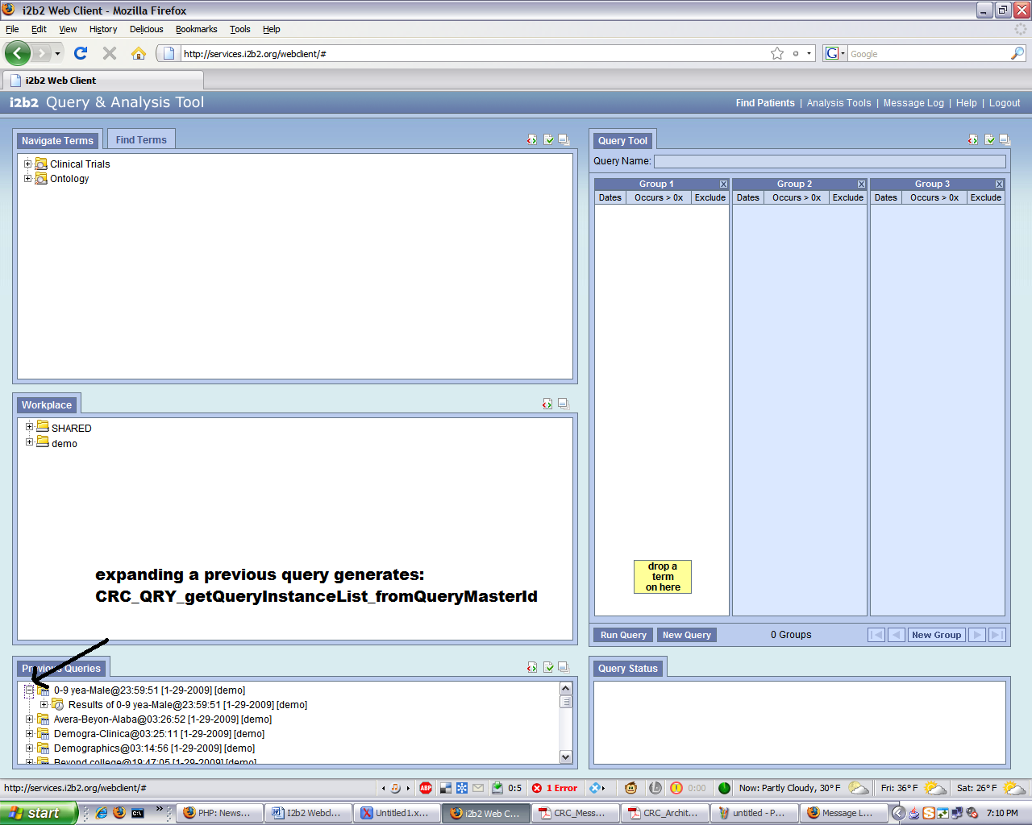

Request XML:

<?xml version="1.0" encoding="UTF-8" standalone="yes"?>
<ns6:request xmlns:ns4="http://www.i2b2.org/xsd/cell/crc/psm/1.1/" xmlns:ns7="http://www.i2b2.org/xsd/cell/crc/psm/querydefinition/1.1/" xmlns:ns3="http://www.i2b2.org/xsd/cell/crc/pdo/1.1/" xmlns:ns5="http://www.i2b2.org/xsd/hive/plugin/" xmlns:ns2="http://www.i2b2.org/xsd/hive/pdo/1.1/" xmlns:ns6="http://www.i2b2.org/xsd/hive/msg/1.1/">
<message_header>
<proxy>
<redirect_url>http://services.i2b2.org/i2b2/rest/QueryToolService/request</redirect_url>
</proxy>
<sending_application>
<application_name>i2b2_QueryTool</application_name>
<application_version>0.2</application_version>
</sending_application>
<sending_facility>
<facility_name>PHS</facility_name>
</sending_facility>
<receiving_application>
<application_name>i2b2_DataRepositoryCell</application_name>
<application_version>0.2</application_version>
</receiving_application>
<receiving_facility>
<facility_name>PHS</facility_name>
</receiving_facility>
<security>
<domain>HarvardDemo</domain>
<username>demo</username>
<password>demouser</password>
</security>
<message_type>
<message_code>Q04</message_code>
<event_type>EQQ</event_type>
</message_type>
<message_control_id>
<message_num>fVBJ0m7p1029h8P19VAAv</message_num>
<instance_num>0</instance_num>
</message_control_id>
<processing_id>
<processing_id>P</processing_id>
<processing_mode>I</processing_mode>
</processing_id>
<accept_acknowledgement_type>messageId</accept_acknowledgement_type>
<project_id>Demo</project_id>
</message_header>
<request_header>
<result_waittime_ms>180000</result_waittime_ms>
</request_header>
<message_body>
<ns4:psmheader>
<user login="demo">demo</user>
<patient_set_limit>0</patient_set_limit>
<estimated_time>0</estimated_time>
<request_type>CRC_QRY_getQueryInstanceList_fromQueryMasterId</request_type>
</ns4:psmheader>
<ns4:request xsi:type="ns4:master_requestType" xmlns:xsi="http://www.w3.org/2001/XMLSchema-instance">
<query_master_id>9048</query_master_id>
</ns4:request>
</message_body>
</ns6:request>
GREEN: Query name + parameters. The query_master_id is known from a previous CRC_QRY_getQueryMasterList_fromUserId call.

Response XML:

<?xml version="1.0" encoding="UTF-8"?>
<ns5:response xmlns:tns="http://axis2.crc.i2b2.harvard.edu"
xmlns:ns9="http://www.i2b2.org/xsd/hive/msg/result/1.1/"
xmlns:ns4="http://www.i2b2.org/xsd/cell/crc/psm/1.1/"
xmlns:ns7="http://www.i2b2.org/xsd/cell/pm/1.1/"
xmlns:ns3="http://www.i2b2.org/xsd/cell/crc/pdo/1.1/"
xmlns:ns5="http://www.i2b2.org/xsd/hive/msg/1.1/"
xmlns:ns2="http://www.i2b2.org/xsd/hive/pdo/1.1/"
xmlns:ns6="http://www.i2b2.org/xsd/cell/crc/psm/querydefinition/1.1/"
xmlns:ns8="http://www.i2b2.org/xsd/cell/ont/1.1/">
<message_header>
<i2b2_version_compatible>1.1</i2b2_version_compatible>
<hl7_version_compatible>2.4</hl7_version_compatible>
<sending_application>
<application_name>edu.harvard.i2b2.crc</application_name>
<application_version>1.3</application_version>
</sending_application>
<sending_facility>
<facility_name>i2b2 Hive</facility_name>
</sending_facility>
<receiving_application>
<application_name>i2b2_QueryTool</application_name>
<application_version>0.2</application_version>
</receiving_application>
<receiving_facility>
<facility_name>i2b2 Hive</facility_name>
</receiving_facility>
<message_control_id>
<instance_num>1</instance_num>
</message_control_id>
<project_id>Demo</project_id>
</message_header>
<response_header>
<info>Log information</info>
<result_status>
<status type="DONE">DONE</status>
<polling_url interval_ms="100"/>
</result_status>
</response_header>
<message_body>
<ns4:response xmlns:xsi="http://www.w3.org/2001/XMLSchema-instance"
xsi:type="ns4:instance_responseType">
<status>
<condition type="DONE">DONE</condition>
</status>
<query_instance>
<query_instance_id>9028</query_instance_id>
<query_master_id>9048</query_master_id>
<user_id>demo</user_id>
<batch_mode>Demo</batch_mode>
<start_date>2009-01-29T19:00:08.000-05:00</start_date>
<end_date>2009-01-29T19:00:08.000-05:00</end_date>
<query_status_type>
<status_type_id>6</status_type_id>
<name>COMPLETED</name>
</query_status_type>
</query_instance>
</ns4:response>
</message_body>
</ns5:response>

GREEN: The query instance ID(s) that we requested.

CRC: CRC_QRY_getQueryResultInstanceList_fromQueryInstanceId

This query is generated when we expand the previous Query Instance to show the Query Results:

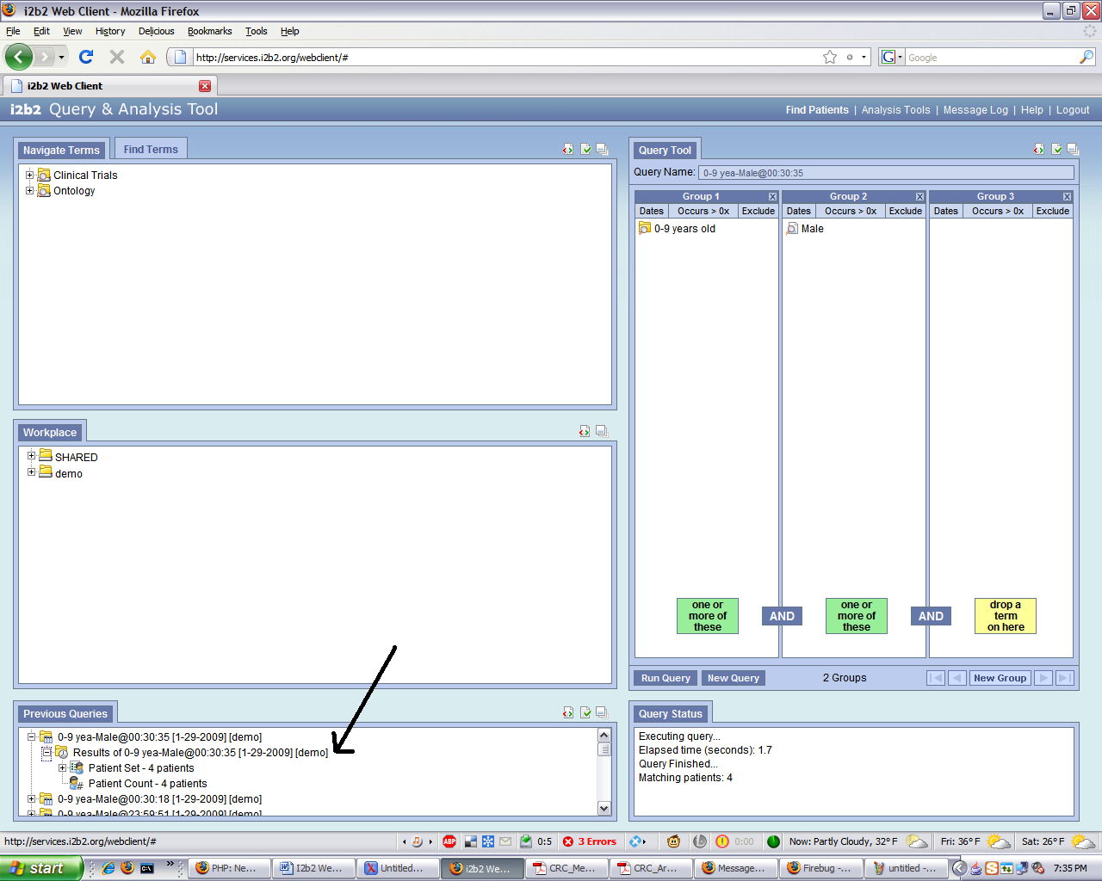

Request XML:

<?xml version="1.0" encoding="UTF-8" standalone="yes"?>
<ns6:request xmlns:ns4="http://www.i2b2.org/xsd/cell/crc/psm/1.1/" xmlns:ns7="http://www.i2b2.org/xsd/cell/crc/psm/querydefinition/1.1/" xmlns:ns3="http://www.i2b2.org/xsd/cell/crc/pdo/1.1/" xmlns:ns5="http://www.i2b2.org/xsd/hive/plugin/" xmlns:ns2="http://www.i2b2.org/xsd/hive/pdo/1.1/" xmlns:ns6="http://www.i2b2.org/xsd/hive/msg/1.1/">
<message_header>
<proxy>
<redirect_url>http://services.i2b2.org/i2b2/rest/QueryToolService/request</redirect_url>
</proxy>
<sending_application>
<application_name>i2b2_QueryTool</application_name>
<application_version>0.2</application_version>
</sending_application>
<sending_facility>
<facility_name>PHS</facility_name>
</sending_facility>
<receiving_application>
<application_name>i2b2_DataRepositoryCell</application_name>
<application_version>0.2</application_version>
</receiving_application>
<receiving_facility>
<facility_name>PHS</facility_name>
</receiving_facility>
<security>
<domain>HarvardDemo</domain>
<username>demo</username>
<password>demouser</password>
</security>
<message_type>
<message_code>Q04</message_code>
<event_type>EQQ</event_type>
</message_type>
<message_control_id>
<message_num>6r8T6p2yZj3hr8YOvBM14</message_num>
<instance_num>0</instance_num>
</message_control_id>
<processing_id>
<processing_id>P</processing_id>
<processing_mode>I</processing_mode>
</processing_id>
<accept_acknowledgement_type>messageId</accept_acknowledgement_type>
<project_id>Demo</project_id>
</message_header>
<request_header>
<result_waittime_ms>180000</result_waittime_ms>
</request_header>
<message_body>
<ns4:psmheader>
<user login="demo">demo</user>
<patient_set_limit>0</patient_set_limit>
<estimated_time>0</estimated_time>
<request_type>CRC_QRY_getQueryResultInstanceList_fromQueryInstanceId</request_type>
</ns4:psmheader>
<ns4:request xsi:type="ns4:instance_requestType" xmlns:xsi="http://www.w3.org/2001/XMLSchema-instance">
<query_instance_id>9028</query_instance_id>
</ns4:request>
</message_body>
</ns6:request>
Response XML:

<?xml version="1.0" encoding="UTF-8"?>
<ns5:response xmlns:tns="http://axis2.crc.i2b2.harvard.edu"
xmlns:ns9="http://www.i2b2.org/xsd/hive/msg/result/1.1/"
xmlns:ns4="http://www.i2b2.org/xsd/cell/crc/psm/1.1/"
xmlns:ns7="http://www.i2b2.org/xsd/cell/pm/1.1/"
xmlns:ns3="http://www.i2b2.org/xsd/cell/crc/pdo/1.1/"
xmlns:ns5="http://www.i2b2.org/xsd/hive/msg/1.1/"
xmlns:ns2="http://www.i2b2.org/xsd/hive/pdo/1.1/"
xmlns:ns6="http://www.i2b2.org/xsd/cell/crc/psm/querydefinition/1.1/"
xmlns:ns8="http://www.i2b2.org/xsd/cell/ont/1.1/">
<message_header>
<i2b2_version_compatible>1.1</i2b2_version_compatible>
<hl7_version_compatible>2.4</hl7_version_compatible>
<sending_application>
<application_name>edu.harvard.i2b2.crc</application_name>
<application_version>1.3</application_version>
</sending_application>
<sending_facility>
<facility_name>i2b2 Hive</facility_name>
</sending_facility>
<receiving_application>
<application_name>i2b2_QueryTool</application_name>
<application_version>0.2</application_version>
</receiving_application>
<receiving_facility>
<facility_name>i2b2 Hive</facility_name>
</receiving_facility>
<message_control_id>
<instance_num>1</instance_num>
</message_control_id>
<project_id>Demo</project_id>
</message_header>
<response_header>
<info>Log information</info>
<result_status>
<status type="DONE">DONE</status>
<polling_url interval_ms="100"/>
</result_status>
</response_header>
<message_body>
<ns4:response xmlns:xsi="http://www.w3.org/2001/XMLSchema-instance"
xsi:type="ns4:result_responseType">
<status>
<condition type="DONE">DONE</condition>
</status>
<query_result_instance>
<result_instance_id>9200</result_instance_id>
<query_instance_id>9028</query_instance_id>
<query_result_type>
<result_type_id>1</result_type_id>
<name>PATIENTSET</name>
<description>Patient list</description>
</query_result_type>
<set_size>4</set_size>
<start_date>2009-01-29T19:00:08.000-05:00</start_date>
<end_date>2009-01-29T19:00:09.000-05:00</end_date>
<query_status_type>
<status_type_id>3</status_type_id>
<name>FINISHED</name>
<description>FINISHED</description>
</query_status_type>
</query_result_instance>
<query_result_instance>
<result_instance_id>9201</result_instance_id>
<query_instance_id>9028</query_instance_id>
<query_result_type>
<result_type_id>4</result_type_id>
<name>PATIENT_COUNT_XML</name>
<description>Number of patients</description>
</query_result_type>
<set_size>4</set_size>
<start_date>2009-01-29T19:00:09.000-05:00</start_date>
<end_date>2009-01-29T19:00:09.000-05:00</end_date>
<query_status_type>
<status_type_id>3</status_type_id>
<name>FINISHED</name>
<description>FINISHED</description>
</query_status_type>
</query_result_instance>
</ns4:response>
</message_body>
</ns5:response>
GREEN: Here you see two actual QueryResultInstances belonging to the QueryInstance. A “Patient Set” with id 9200 (and its set size) and a PATIENT_COUNT_XML with id 9201 (and its set size). These are the same ids that can be used to fetch results both from the PDO (in the case of a set) and from the PSM in the case of a query that returned before the specified time for the client.

If we were to click on the “Patient Set 4 Patients” icon under our QueryInstance (i.e. expanding a QueryResultInstance of type “set”) a PDO request would get generated to the CRC:

Request XML of a PDO request:

<?xml version="1.0" encoding="UTF-8" standalone="yes"?>
<ns6:request xmlns:ns4="http://www.i2b2.org/xsd/cell/crc/psm/1.1/"
xmlns:ns7="http://www.i2b2.org/xsd/cell/crc/psm/querydefinition/1.1/"
xmlns:ns3="http://www.i2b2.org/xsd/cell/crc/pdo/1.1/"
xmlns:ns5="http://www.i2b2.org/xsd/hive/plugin/"
xmlns:ns2="http://www.i2b2.org/xsd/hive/pdo/1.1/"
xmlns:ns6="http://www.i2b2.org/xsd/hive/msg/1.1/">
<message_header>
<proxy>
<redirect_url>http://services.i2b2.org/i2b2/rest/QueryToolService/pdorequest</redirect_url>
</proxy>
<sending_application>
<application_name>i2b2_QueryTool</application_name>
<application_version>0.2</application_version>
</sending_application>
<sending_facility>
<facility_name>PHS</facility_name>
</sending_facility>
<receiving_application>
<application_name>i2b2_DataRepositoryCell</application_name>
<application_version>0.2</application_version>
</receiving_application>
<receiving_facility>
<facility_name>PHS</facility_name>
</receiving_facility>
<message_type>
<message_code>Q04</message_code>
<event_type>EQQ</event_type>
</message_type>
<security>
<domain>HarvardDemo</domain>
<username>demo</username>
<password>demouser</password>
</security>
<message_control_id>
<message_num>q0yvE14vCMsJ21c4cdCXF</message_num>
<instance_num>0</instance_num>
</message_control_id>
<processing_id>
<processing_id>P</processing_id>
<processing_mode>I</processing_mode>
</processing_id>
<accept_acknowledgement_type>messageId</accept_acknowledgement_type>
<project_id>Demo</project_id>
</message_header>
<request_header>
<result_waittime_ms>900000</result_waittime_ms>
</request_header>
<message_body>
<ns3:pdoheader>
<patient_set_limit>0</patient_set_limit>
<estimated_time>900000</estimated_time>
<request_type>getPDO_fromInputList</request_type>
</ns3:pdoheader>
<ns3:request xsi:type="ns3:GetPDOFromInputList_requestType"
xmlns:xsi="http://www.w3.org/2001/XMLSchema-instance">
<input_list>
<patient_list max="1000000" min="0">
<patient_set_coll_id>9200</patient_set_coll_id>
</patient_list>
</input_list>
<filter_list/>
<output_option>
<patient_set select="using_input_list" onlykeys="false"/>
</output_option>
</ns3:request>
</message_body>
</ns6:request>
GREEN: This is the client requesting from the CRC the set of patients from the previous QueryResultInstance of id 9200. The response follows:

Response XML of a PDO request:

<ns5:response xmlns:tns="http://axis2.crc.i2b2.harvard.edu"
xmlns:ns9="http://www.i2b2.org/xsd/hive/msg/result/1.1/"
xmlns:ns4="http://www.i2b2.org/xsd/cell/crc/psm/1.1/"
xmlns:ns7="http://www.i2b2.org/xsd/cell/pm/1.1/"
xmlns:ns3="http://www.i2b2.org/xsd/cell/crc/pdo/1.1/"
xmlns:ns5="http://www.i2b2.org/xsd/hive/msg/1.1/"
xmlns:ns2="http://www.i2b2.org/xsd/hive/pdo/1.1/"
xmlns:ns6="http://www.i2b2.org/xsd/cell/crc/psm/querydefinition/1.1/"
xmlns:ns8="http://www.i2b2.org/xsd/cell/ont/1.1/">
<message_header>
<i2b2_version_compatible>1.1</i2b2_version_compatible>
<hl7_version_compatible>2.4</hl7_version_compatible>
<sending_application>
<application_name>edu.harvard.i2b2.crc</application_name>
<application_version>1.3</application_version>
</sending_application>
<sending_facility>
<facility_name>i2b2 Hive</facility_name>
</sending_facility>
<receiving_application>
<application_name>i2b2_QueryTool</application_name>
<application_version>0.2</application_version>
</receiving_application>
<receiving_facility>
<facility_name>i2b2 Hive</facility_name>
</receiving_facility>
<message_control_id>
<instance_num>1</instance_num>
</message_control_id>
<project_id>Demo</project_id>
</message_header>
<response_header>
<info>Log information</info>
<result_status>
<status type="DONE">DONE</status>
<polling_url interval_ms="100"/>
</result_status>
</response_header>
<message_body>
<ns3:response xmlns:xsi="http://www.w3.org/2001/XMLSchema-instance"
xsi:type="ns3:patient_data_responseType">
<ns2:patient_data>
<ns2:patient_set>
<patient>
<patient_id>1000000019</patient_id>
<param name="vital_status_cd" column="vital_status_cd">N</param>
<param name="birth_date" column="birth_date"
>1999-02-05T00:00:00.000-05:00</param>
<param name="sex_cd" column="sex_cd">M</param>
<param name="age_in_years_num" column="age_in_years_num">8</param>
<param name="language_cd" column="language_cd">german</param>
<param name="race_cd" column="race_cd">indian</param>
<param name="religion_cd" column="religion_cd">christian</param>
<param name="marital_status_cd" column="marital_status_cd">single</param>
<param name="zipcode_char" column="zipcode_char"/>
<param name="statecityzip_path_char" column="statecityzip_path_char"/>
</patient>
<patient>
<patient_id>1000000065</patient_id>
<param name="vital_status_cd" column="vital_status_cd">N</param>
<param name="birth_date" column="birth_date"
>2000-06-07T00:00:00.000-04:00</param>
<param name="sex_cd" column="sex_cd">M</param>
<param name="age_in_years_num" column="age_in_years_num">6</param>
<param name="language_cd" column="language_cd">english</param>
<param name="race_cd" column="race_cd">asian</param>
<param name="religion_cd" column="religion_cd">atheist</param>
<param name="marital_status_cd" column="marital_status_cd">single</param>
<param name="zipcode_char" column="zipcode_char"/>
<param name="statecityzip_path_char" column="statecityzip_path_char"/>
</patient>
<patient>
<patient_id>1000000117</patient_id>
<param name="vital_status_cd" column="vital_status_cd">N</param>
<param name="birth_date" column="birth_date"
>1997-09-25T00:00:00.000-04:00</param>
<param name="sex_cd" column="sex_cd">M</param>
<param name="age_in_years_num" column="age_in_years_num">9</param>
<param name="language_cd" column="language_cd">english</param>
<param name="race_cd" column="race_cd">indian</param>
<param name="religion_cd" column="religion_cd">jewish</param>
<param name="marital_status_cd" column="marital_status_cd">single</param>
<param name="zipcode_char" column="zipcode_char"/>
<param name="statecityzip_path_char" column="statecityzip_path_char"/>
</patient>
<patient>
<patient_id>1000000132</patient_id>
<param name="vital_status_cd" column="vital_status_cd">N</param>
<param name="birth_date" column="birth_date"
>1998-08-30T00:00:00.000-04:00</param>
<param name="sex_cd" column="sex_cd">M</param>
<param name="age_in_years_num" column="age_in_years_num">8</param>
<param name="language_cd" column="language_cd">german</param>
<param name="race_cd" column="race_cd">hispanic</param>
<param name="religion_cd" column="religion_cd">atheist</param>
<param name="marital_status_cd" column="marital_status_cd">single</param>
<param name="zipcode_char" column="zipcode_char"/>
<param name="statecityzip_path_char" column="statecityzip_path_char"/>
</patient>
</ns2:patient_set>
</ns2:patient_data>
</ns3:response>
</message_body>
</ns5:response>

GREEN: Here is the set of patients (4). The information that is returned by the CRC is more than the information we queried (sex and age) but the webclient only shows you what you queried (sex/age). It’s not clear whether for our Shrine demo we need to support PDO requests. But this is how they work.

CRC Cell: CRC_QRY_runQueryInstance_fromQueryDefinition

This is a query performed when building a query with the web-client tool:

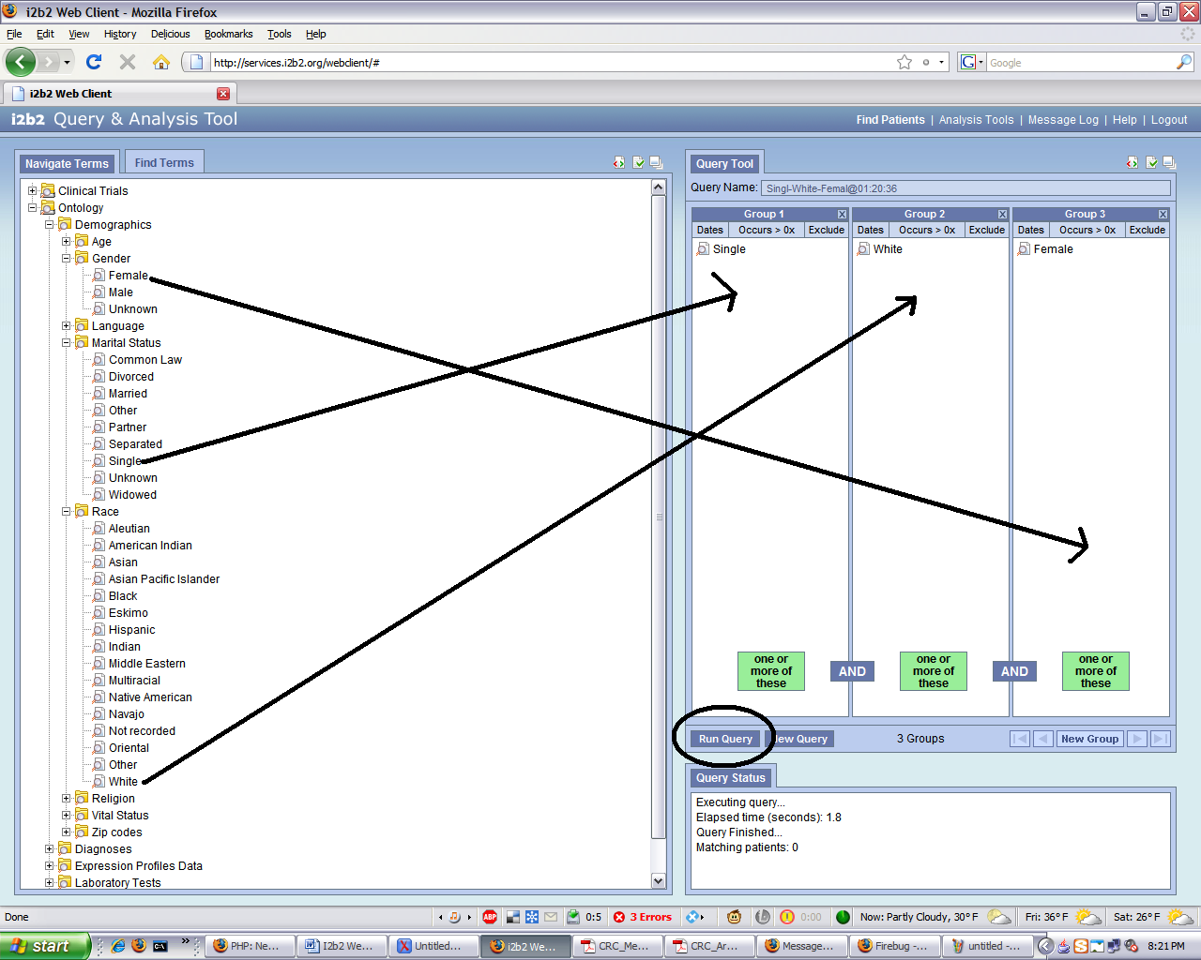

Request XML:

<?xml version="1.0" encoding="UTF-8" standalone="yes"?>
<ns6:request xmlns:ns4="http://www.i2b2.org/xsd/cell/crc/psm/1.1/" xmlns:ns7="http://www.i2b2.org/xsd/cell/ont/1.1/" xmlns:ns3="http://www.i2b2.org/xsd/cell/crc/pdo/1.1/" xmlns:ns5="http://www.i2b2.org/xsd/hive/plugin/" xmlns:ns2="http://www.i2b2.org/xsd/hive/pdo/1.1/" xmlns:ns6="http://www.i2b2.org/xsd/hive/msg/1.1/" xmlns:ns8="http://www.i2b2.org/xsd/cell/crc/psm/querydefinition/1.1/">
<message_header>
<proxy>
<redirect_url>http://services.i2b2.org/i2b2/rest/QueryToolService/request</redirect_url>
</proxy>
<sending_application>
<application_name>i2b2_QueryTool</application_name>
<application_version>0.2</application_version>
</sending_application>
<sending_facility>
<facility_name>PHS</facility_name>
</sending_facility>
<receiving_application>
<application_name>i2b2_DataRepositoryCell</application_name>
<application_version>0.2</application_version>
</receiving_application>
<receiving_facility>
<facility_name>PHS</facility_name>
</receiving_facility>
<security>
<domain>HarvardDemo</domain>
<username>demo</username>
<password>demouser</password>
</security>
<message_type>
<message_code>Q04</message_code>
<event_type>EQQ</event_type>
</message_type>
<message_control_id>
<message_num>3D8w3A37QK0XKg647k6q8</message_num>
<instance_num>0</instance_num>
</message_control_id>
<processing_id>
<processing_id>P</processing_id>
<processing_mode>I</processing_mode>
</processing_id>
<accept_acknowledgement_type>messageId</accept_acknowledgement_type>
<project_id>Demo</project_id>
</message_header>
<request_header>
<result_waittime_ms>180000</result_waittime_ms>
</request_header>
<message_body>
<ns4:psmheader>
<user group="Demo" login="demo">demo</user>
<patient_set_limit>0</patient_set_limit>
<estimated_time>0</estimated_time>
<request_type>CRC_QRY_runQueryInstance_fromQueryDefinition</request_type>
</ns4:psmheader>
<ns4:request xsi:type="ns4:query_definition_requestType" xmlns:xsi="http://www.w3.org/2001/XMLSchema-instance">
<query_definition>
<query_name>Singl-White-Femal@01:20:36</query_name>
<specificity_scale>0</specificity_scale>
<panel>
<panel_number>1</panel_number>
<invert>0</invert>
<total_item_occurrences>1</total_item_occurrences>
<item>
<hlevel>3</hlevel>
<item_name>Single</item_name>
<item_key>\\i2b2\i2b2\Demographics\Marital Status\Single\</item_key>
<tooltip>Demographic \ Marital Status \ Single</tooltip>
<class>ENC</class>
<constrain_by_date>
</constrain_by_date>
<item_icon>MA</item_icon>
<item_is_synonym>false</item_is_synonym>
</item>
</panel>
<panel>
<panel_number>2</panel_number>
<invert>0</invert>
<total_item_occurrences>1</total_item_occurrences>
<item>
<hlevel>3</hlevel>
<item_name>White</item_name>
<item_key>\\i2b2\i2b2\Demographics\Race\White\</item_key>
<tooltip>Demographic \ Race \ White</tooltip>
<class>ENC</class>
<constrain_by_date>
</constrain_by_date>
<item_icon>MA</item_icon>
<item_is_synonym>false</item_is_synonym>
</item>
</panel>
<panel>
<panel_number>3</panel_number>
<invert>0</invert>
<total_item_occurrences>1</total_item_occurrences>
<item>
<hlevel>3</hlevel>
<item_name>Female</item_name>
<item_key>\\i2b2\i2b2\Demographics\Gender\Female\</item_key>
<tooltip>Demographic \ Gender \ Female</tooltip>
<class>ENC</class>
<constrain_by_date>
</constrain_by_date>
<item_icon>LA</item_icon>
<item_is_synonym>false</item_is_synonym>
</item>
</panel>
</query_definition>
<result_output_list>
<result_output priority_index="1" name="patientset"/>
<result_output priority_index="2" name="patient_count_xml"/>
</result_output_list>
</ns4:request>
</message_body>
</ns6:request>
GREEN: You can see the CRC_QRY_runQueryInstance_fromQueryDefinition request as well as the “panels” which mirror the UI definition of a panel: a container where one or more “items” from the ontology can be dropped and arranged to create complex queries.
YELLOW: These the actual “types” of queries embedded into this request (Patient Count, Patient Set, and Gender Count which does not seem to be implemented here). When the user runs the query in the web-client, the following dialog box comes up:

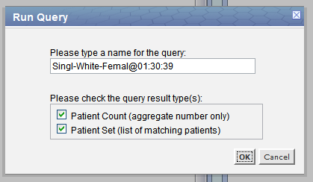

Selecting both Patient Count and Patient Set produced the additional XML request.

Response XML:

<ns5:response xmlns:tns="http://axis2.crc.i2b2.harvard.edu"
xmlns:ns9="http://www.i2b2.org/xsd/hive/msg/result/1.1/"
xmlns:ns4="http://www.i2b2.org/xsd/cell/crc/psm/1.1/"
xmlns:ns7="http://www.i2b2.org/xsd/cell/pm/1.1/"
xmlns:ns3="http://www.i2b2.org/xsd/cell/crc/pdo/1.1/"
xmlns:ns5="http://www.i2b2.org/xsd/hive/msg/1.1/"
xmlns:ns2="http://www.i2b2.org/xsd/hive/pdo/1.1/"
xmlns:ns6="http://www.i2b2.org/xsd/cell/crc/psm/querydefinition/1.1/"
xmlns:ns8="http://www.i2b2.org/xsd/cell/ont/1.1/">
<message_header>
<i2b2_version_compatible>1.1</i2b2_version_compatible>
<hl7_version_compatible>2.4</hl7_version_compatible>
<sending_application>
<application_name>edu.harvard.i2b2.crc</application_name>
<application_version>1.3</application_version>
</sending_application>
<sending_facility>
<facility_name>i2b2 Hive</facility_name>
</sending_facility>
<receiving_application>
<application_name>i2b2_QueryTool</application_name>
<application_version>0.2</application_version>
</receiving_application>
<receiving_facility>
<facility_name>i2b2 Hive</facility_name>
</receiving_facility>
<message_control_id>
<instance_num>1</instance_num>
</message_control_id>
<project_id>Demo</project_id>
</message_header>
<response_header>
<info>Log information</info>
<result_status>
<status type="DONE">DONE</status>
<polling_url interval_ms="100"/>
</result_status>
</response_header>
<message_body>
<ns4:response xmlns:xsi="http://www.w3.org/2001/XMLSchema-instance"
xsi:type="ns4:master_instance_result_responseType">
<status>
<condition type="DONE">DONE</condition>
</status>
<query_master>
<query_master_id>9051</query_master_id>
<name>Singl-White-Femal@01:20:36</name>
<user_id>demo</user_id>
<group_id>Demo</group_id>
<create_date>2009-01-29T20:20:45.000-05:00</create_date>
<request_xml>&lt;?xml version="1.0" encoding="UTF-8"
standalone="yes"?>&lt;ns2:query_definition
xmlns:ns2="http://www.i2b2.org/xsd/cell/crc/psm/querydefinition/1.1/">
&lt;query_name>Singl-White-Femal@01:20:36&lt;/query_name>
&lt;specificity_scale>0&lt;/specificity_scale> &lt;panel>
&lt;panel_number>1&lt;/panel_number>
&lt;panel_accuracy_scale>0&lt;/panel_accuracy_scale>
&lt;invert>0&lt;/invert>
&lt;total_item_occurrences>1&lt;/total_item_occurrences> &lt;item>
&lt;hlevel>3&lt;/hlevel> &lt;item_name>Single&lt;/item_name>
&lt;item_key>\\i2b2\i2b2\Demographics\Marital
Status\Single\&lt;/item_key> &lt;item_icon>MA&lt;/item_icon>
&lt;tooltip>Demographic \ Marital Status \ Single&lt;/tooltip>
&lt;class>ENC&lt;/class> &lt;constrain_by_date/>
&lt;item_is_synonym>false&lt;/item_is_synonym> &lt;/item>
&lt;/panel> &lt;panel> &lt;panel_number>2&lt;/panel_number>
&lt;panel_accuracy_scale>0&lt;/panel_accuracy_scale>
&lt;invert>0&lt;/invert>
&lt;total_item_occurrences>1&lt;/total_item_occurrences> &lt;item>
&lt;hlevel>3&lt;/hlevel> &lt;item_name>White&lt;/item_name>
&lt;item_key>\\i2b2\i2b2\Demographics\Race\White\&lt;/item_key>
&lt;item_icon>MA&lt;/item_icon> &lt;tooltip>Demographic \ Race \
White&lt;/tooltip> &lt;class>ENC&lt;/class>
&lt;constrain_by_date/>
&lt;item_is_synonym>false&lt;/item_is_synonym> &lt;/item>
&lt;/panel> &lt;panel> &lt;panel_number>3&lt;/panel_number>
&lt;panel_accuracy_scale>0&lt;/panel_accuracy_scale>
&lt;invert>0&lt;/invert>
&lt;total_item_occurrences>1&lt;/total_item_occurrences> &lt;item>
&lt;hlevel>3&lt;/hlevel> &lt;item_name>Female&lt;/item_name>
&lt;item_key>\\i2b2\i2b2\Demographics\Gender\Female\&lt;/item_key>
&lt;item_icon>LA&lt;/item_icon> &lt;tooltip>Demographic \ Gender \
Female&lt;/tooltip> &lt;class>ENC&lt;/class>
&lt;constrain_by_date/>
&lt;item_is_synonym>false&lt;/item_is_synonym> &lt;/item>
&lt;/panel>&lt;/ns2:query_definition></request_xml>
</query_master>
<query_instance>
<query_instance_id>9031</query_instance_id>
<query_master_id>9051</query_master_id>
<user_id>demo</user_id>
<group_id>Demo</group_id>
<start_date>2009-01-29T20:20:45.000-05:00</start_date>
<end_date>2009-01-29T20:20:45.000-05:00</end_date>
<query_status_type>
<status_type_id>6</status_type_id>
<name>COMPLETED</name>
<description>COMPLETED</description>
</query_status_type>
</query_instance>
<query_result_instance>
<result_instance_id>9206</result_instance_id>
<query_instance_id>9031</query_instance_id>
<query_result_type>
<result_type_id>1</result_type_id>
<name>PATIENTSET</name>
<description>Patient list</description>
</query_result_type>
<set_size>0</set_size>
<start_date>2009-01-29T20:20:45.000-05:00</start_date>
<end_date>2009-01-29T20:20:45.000-05:00</end_date>
<query_status_type>
<status_type_id>3</status_type_id>
<name>FINISHED</name>
<description>FINISHED</description>
</query_status_type>
</query_result_instance>
<query_result_instance>
<result_instance_id>9207</result_instance_id>
<query_instance_id>9031</query_instance_id>
<query_result_type>
<result_type_id>4</result_type_id>
<name>PATIENT_COUNT_XML</name>
<description>Number of patients</description>
</query_result_type>
<set_size>0</set_size>
<start_date>2009-01-29T20:20:45.000-05:00</start_date>
<end_date>2009-01-29T20:20:45.000-05:00</end_date>
<query_status_type>
<status_type_id>3</status_type_id>
<name>FINISHED</name>
<description>FINISHED</description>
</query_status_type>
</query_result_instance>
</ns4:response>
</message_body>
</ns5:response>
RED: QueryMaster id given to us by the CRC. The CRC will log the query name in the user’s history, after the query returns the webclient will again ask for the QueryMasterList_fromUserId to refresh the “Previous Query” panel and the just-ran query will show up on the UI.

GRAY: The original request is embedded.

YELLOW: So our QueryMaster 9051 has a QueryInstance 9031 with status = “COMPLETED”. This query_instance_id (9031) is the id that can be used to re-query the CRC in case of a status = “RUNNING” etc.

GREEN: Then our QueryInstance has QueryResultInstances 9206, 9207 one for PATIENTSET and one for PATIENT_COUNT_XML.

Request XML, query the CRC with a 1 second limit:

<?xml version="1.0" encoding="UTF-8" standalone="yes"?>
<ns6:request xmlns:ns4="http://www.i2b2.org/xsd/cell/crc/psm/1.1/" xmlns:ns7="http://www.i2b2.org/xsd
/cell/ont/1.1/" xmlns:ns3="http://www.i2b2.org/xsd/cell/crc/pdo/1.1/" xmlns:ns5="http://www.i2b2.org
/xsd/hive/plugin/" xmlns:ns2="http://www.i2b2.org/xsd/hive/pdo/1.1/" xmlns:ns6="http://www.i2b2.org/xsd
/hive/msg/1.1/" xmlns:ns8="http://www.i2b2.org/xsd/cell/crc/psm/querydefinition/1.1/">
<message_header>
<proxy>
<redirect_url>http://134.174.151.208:9090/i2b2/rest/QueryToolService/request</redirect_url
>
</proxy>
<sending_application>
<application_name>i2b2_QueryTool</application_name>
<application_version>0.2</application_version>
</sending_application>
<sending_facility>
<facility_name>PHS</facility_name>
</sending_facility>
<receiving_application>
<application_name>i2b2_DataRepositoryCell</application_name>
<application_version>0.2</application_version>
</receiving_application>
<receiving_facility>
<facility_name>PHS</facility_name>
</receiving_facility>
<security>
<domain>i2b2demo</domain>
<username>demo</username>
<password>demouser</password>
</security>
<message_type>
<message_code>Q04</message_code>
<event_type>EQQ</event_type>
</message_type>
<message_control_id>
<message_num>1gjtB0Nq2FnanFrJ5s511</message_num>
<instance_num>0</instance_num>
</message_control_id>
<processing_id>
<processing_id>P</processing_id>
<processing_mode>I</processing_mode>
</processing_id>
<accept_acknowledgement_type>messageId</accept_acknowledgement_type>
<project_id>Demo</project_id>
</message_header>
<request_header>
<result_waittime_ms>1000</result_waittime_ms>
</request_header>
<message_body>
<ns4:psmheader>
<user group="Demo" login="demo">demo</user>
<patient_set_limit>0</patient_set_limit>
<estimated_time>0</estimated_time>
<request_type>CRC_QRY_runQueryInstance_fromQueryDefinition</request_type>
</ns4:psmheader>
<ns4:request xsi:type="ns4:query_definition_requestType" xmlns:xsi="http://www.w3.org/2001/XMLSchema-instance"
>
<query_definition>
<query_name>Demogra-Oasis@00:30:10</query_name>
<specificity_scale>0</specificity_scale>
<panel>
<panel_number>1</panel_number>
<invert>0</invert>
<total_item_occurrences>1</total_item_occurrences>
<item>
<hlevel>1</hlevel>
<item_name>Demographics</item_name>
<item_key>\\i2b2\i2b2\Demographics</item_key>
<tooltip>Demographic</tooltip>
<class>ENC</class>
<constrain_by_date/>
<item_icon>FA</item_icon>
<item_is_synonym>false</item_is_synonym>
</item>
</panel>
<panel>
<panel_number>2</panel_number>
<invert>0</invert>
<total_item_occurrences>1</total_item_occurrences>
<item>
<hlevel>1</hlevel>
<item_name>Oasis</item_name>
<item_key>\\BIRN\BIRN\oasis</item_key>
<tooltip>oasis</tooltip>
<class>ENC</class>
<constrain_by_date/>
<item_icon>FA</item_icon>
<item_is_synonym>false</item_is_synonym>
</item>
</panel>
</query_definition>
<result_output_list><result_output priority_index="1" name="patient_count_xml"/></result_output_list
>
</ns4:request>
</message_body>
</ns6:request>

Response XML, query the CRC with a 1 second limit:

<ns5:response xmlns:tns="http://axis2.crc.i2b2.harvard.edu" xmlns:ns9="http://www.i2b2.org/xsd/hive/msg
/result/1.1/" xmlns:ns4="http://www.i2b2.org/xsd/cell/crc/psm/1.1/" xmlns:ns7="http://www.i2b2.org/xsd
/cell/pm/1.1/" xmlns:ns3="http://www.i2b2.org/xsd/cell/crc/pdo/1.1/" xmlns:ns5="http://www.i2b2.org/xsd
/hive/msg/1.1/" xmlns:ns2="http://www.i2b2.org/xsd/hive/pdo/1.1/" xmlns:ns6="http://www.i2b2.org/xsd
/cell/crc/psm/querydefinition/1.1/" xmlns:ns8="http://www.i2b2.org/xsd/cell/ont/1.1/">
<message_header>
<i2b2_version_compatible>1.1</i2b2_version_compatible>
<hl7_version_compatible>2.4</hl7_version_compatible>
<sending_application>
<application_name>edu.harvard.i2b2.crc</application_name>
<application_version>1.3</application_version>
</sending_application>
<sending_facility>
<facility_name>i2b2 Hive</facility_name>
</sending_facility>
<receiving_application>
<application_name>i2b2_QueryTool</application_name>
<application_version>0.2</application_version>
</receiving_application>
<receiving_facility>
<facility_name>i2b2 Hive</facility_name>
</receiving_facility>
<message_control_id>
<instance_num>1</instance_num>
</message_control_id>
<project_id>Demo</project_id>
</message_header>
<response_header>
<info>Log information</info>
<result_status>
<status type="DONE">DONE</status>
<polling_url interval_ms="100" />
</result_status>
</response_header>
<message_body>
<ns4:response xmlns:xsi="http://www.w3.org/2001/XMLSchema-instance" xsi:type="ns4:master_instance_result_responseType"
>
<status>
<condition type="RUNNING">RUNNING</condition>
</status>
<query_master>
<query_master_id>105</query_master_id>
<name>Demogra-Oasis@00:30:10</name>
<user_id>demo</user_id>
<group_id>Demo</group_id>
<create_date>2009-01-21T19:28:44.000-05:00</create_date>
<request_xml>&lt;?xml version="1.0" encoding="UTF-8" standalone="yes"?>
&lt;ns2:query_definition xmlns:ns2="http://www.i2b2.org/xsd/cell/crc/psm/querydefinition/1.1/">
&lt;query_name>Demogra-Oasis@00:30:10&lt;/query_name>
&lt;specificity_scale>0&lt;/specificity_scale>
&lt;panel>
&lt;panel_number>1&lt;/panel_number>
&lt;panel_accuracy_scale>0&lt;/panel_accuracy_scale>
&lt;invert>0&lt;/invert>
&lt;total_item_occurrences>1&lt;/total_item_occurrences>
&lt;item>
&lt;hlevel>1&lt;/hlevel>
&lt;item_name>Demographics&lt;/item_name>
&lt;item_key>\\i2b2\i2b2\Demographics&lt;/item_key>
&lt;item_icon>FA&lt;/item_icon>
&lt;tooltip>Demographic&lt;/tooltip>
&lt;class>ENC&lt;/class>
&lt;constrain_by_date/>
&lt;item_is_synonym>false&lt;/item_is_synonym>
&lt;/item>
&lt;/panel>
&lt;panel>
&lt;panel_number>2&lt;/panel_number>
&lt;panel_accuracy_scale>0&lt;/panel_accuracy_scale>
&lt;invert>0&lt;/invert>
&lt;total_item_occurrences>1&lt;/total_item_occurrences>
&lt;item>
&lt;hlevel>1&lt;/hlevel>
&lt;item_name>Oasis&lt;/item_name>
&lt;item_key>\\BIRN\BIRN\oasis&lt;/item_key>
&lt;item_icon>FA&lt;/item_icon>
&lt;tooltip>oasis&lt;/tooltip>
&lt;class>ENC&lt;/class>
&lt;constrain_by_date/>
&lt;item_is_synonym>false&lt;/item_is_synonym>
&lt;/item>
&lt;/panel>
&lt;/ns2:query_definition>
</request_xml>
</query_master>
<query_instance>
<query_instance_id>105</query_instance_id>
<query_master_id>105</query_master_id>
<user_id>demo</user_id>
<group_id>Demo</group_id>
<start_date>2009-01-21T19:28:44.000-05:00</start_date>
<query_status_type>
<status_type_id>5</status_type_id>
<name>INCOMPLETE</name>
<description>INCOMPLETE</description>
</query_status_type>
</query_instance>
<query_result_instance>
<result_instance_id>106</result_instance_id>
<query_instance_id>105</query_instance_id>
<query_result_type>
<result_type_id>4</result_type_id>
<name>PATIENT_COUNT_XML</name>
<description>Number of patients</description>
</query_result_type>
<set_size>0</set_size>
<start_date>2009-01-21T19:28:44.000-05:00</start_date>
<end_date>2009-01-21T19:28:44.000-05:00</end_date>
<query_status_type>
<status_type_id>2</status_type_id>
<name>PROCESSING</name>
<description>PROCESSING</description>
</query_status_type>
</query_result_instance>
</ns4:response>
</message_body>
</ns5:response>

GREY: This status is not useful. Keep this in mind for the following section on how the web-client deals with this situation where the query does not complete in time.

GREEN: This is in the body and the CRC tells us that it is still running the query:
<condition type="RUNNING">RUNNING</condition>

Under the Query Master (id 105), the executing Query Instance (id 105) also tells us that the query is incomplete:

<query_status_type>
<status_type_id>5</status_type_id>
<name>INCOMPLETE</name>
<description>INCOMPLETE</description>
</query_status_type>

RED: The QueryResultInstance (id 106) also tells us the same thing:

<query_status_type>
<status_type_id>2</status_type_id>
<name>PROCESSING</name>
<description>PROCESSING</description>
</query_status_type>

CRC cell, How to re-query: CRC_QRY_getQueryResultInstanceList_fromQueryInstanceId

In the case of the CRC returning something other than a “COMPLETE” status message, we can re-query the CRC with a given Query Instance id. How long before one can resubmit a query? It’s not clear. The status on the header could have been used to give us an indication but this is not used this way:

Request XML:

(Abbreviated and taken from the CRC Messaging spec)
<message_body>
<psmheader>
<user login="demo">demo</user>
<patient_set_limit>0</patient_set_limit>
<estimated_time>0</estimated_time>
<request_type>
CRC_QRY_getQueryResultInstanceList_fromQueryInstanceId
</request_type>
</psmheader>
<request xsi:type="ns4:instance_requestType"
xmlns:xsi="http://www.w3.org/2001/XMLSchema-instance">
<query_instance_id>6280</query_instance_id>
</request>

Response XML:

<response xsi:type="ns5:result_responseType"
xmlns:xsi="http://www.w3.org/2001/XMLSchema-instance" >
<query_result_instance>
<result_instance_id>6280</result_instance_id>
<query_instance_id>6280</query_instance_id>
<query_result_type>
<result_type_id>1</result_type_id>
<name>PATIENTSET</name>
</query_result_type>
<set_size>2000</set_size>
<start_date>2007-09-06T10:42:14.000-04:00</start_date>
<end_date>2007-09-06T10:42:15.000-04:00</end_date>
<query_status_type>
<status_type_id>3</status_type_id>
<name>FINISHED</name>
</query_status_type>
</query_result_instance>
</response>

GREEN: Same as usual.

How does the web client fetch “incomplete” queries?

It doesn’t. The web-client has a 180 second time out which is sufficient time for a CRC to complete a query in our test systems (as well as on the i2b2.org website). Thus the web-client never has to deal with queries that return status=”RUNNING”. It’s been hard to simulate the CRC returning before the <result_waittime_ms> expires but when it was done successfully (when we set it the client to <result_waittime_ms>1000</result_waittime_ms>) the web-client did not resubmit the query. Instead the web-client accepted the query as being successful. Here is the appropriate snippet of javascript from the CRC_ajax.js file from the web-client which contains the code to execute the CRC queries that it supports:

i2b2.CRC.ajax.runQueryInstance_fromQueryDefinition = function(query_definition, scoped_callback, options) {
// this function is used to retreve the child concepts from the ONT cell server
console.group("CALLED i2b2.CRC.ajax.runQueryInstance_fromQueryDefinition()");
console.info("[INPUT 1] query_definition");
console.debug(query_definition);
console.info("[INPUT 2] scoped_callback");
console.dir(scoped_callback);
console.info("[INPUT 3] options");
console.dir(options);

var callbackSuccess = function(transport) {
console.group("[AJAX RESULT i2b2.CRC.ajax.runQueryInstance_fromQueryDefinition]");
console.info("AJAX Transport SUCCESS");
console.dir(transport);
// these are closure variables
var origMsgSent = sMessage;
var origCallback = scoped_callback;
var origUrl = sUrl;
// create our data message to send to the callback function
var cbMsg = {
msgRequest: origMsgSent,
msgResponse: transport.responseText,
msgUrl: origUrl,
error: false
};
// check the status from the message
var xmlRecv = transport.responseXML;
if (!xmlRecv) {
cbMsg.error = true;
cbMsg.errorStatus = transport.status;
cbMsg.errorMsg = "The CRC cell's message could not be interpreted as valid XML.";
console.error(transport.responseText);
} else {
cbMsg.refXML = xmlRecv;
var result_status = xmlRecv.getElementsByTagName('result_status')[0];
var s = xmlRecv.getElementsByTagName('status')[0];
if (s.getAttribute('type') != 'DONE') {
cbMsg.error = true;
cbMsg.errorStatus = transport.status;
cbMsg.errorMsg = "The CRC cell's status message could not understood.";
console.error(transport.responseText);
}
}
// send the result message to the callback function
console.info("i2b2CellMsg sent to callback");
console.dir(cbMsg);
console.groupEnd();
// broadcast a debug message to any sniffers/tools
var sniffPackage = i2b2.h.BuildSniffPack("CRC", "runQueryInstance_fromQueryDefinition", cbMsg, options.reqOrigin);
i2b2.CRC.ajax._SniffMsg.fire(sniffPackage);
// return results to caller
if (getObjectClass(origCallback)=='i2b2_scopedCallback') {
origCallback.callback.call(origCallback.scope, cbMsg);
} else {
origCallback(cbMsg);
}
};

GREEN: You can see how here we are just checking for the “header” status, the one that is always set to “DONE” unless there is a real error on the CRC side. To check to see if a CRC query is really done the tags in the body need to be checked to try to find a:

<status>
<condition type="RUNNING">RUNNING</condition>
</status>

Or a:

<status>
<condition type="DONE">DONE</condition>
</status>

The web-client does none of that. However the message seems to still contain enough information to be parsed for a PATIENT_COUNT_XML (why does the CRC return a size count value when the query is not complete?). The web-client parses this value and displays it as the real value of the count for the “incomplete” query.

List of CRC Queries supported by the web client, some of these I didn’t document but they are self-explanatory:

- getQueryMasterList_fromUserId
- getQueryInstanceList_fromQueryMasterId
- getQueryResultInstanceList_fromQueryInstanceId
- getRequestXml_fromQueryMasterId
- runQueryInstance_fromQueryDefinition
- deleteQueryMaster
- renameQueryMaster
- getPDO_fromInputList

